**Link for github:** <https://github.com/sahersohail013/computervision>

**Task 1:**

We were supposed to compute the HOG features and train classifiers on it i.e., SVM and Random Forest. HOG is an algorithm which helps with object detection in computer vision and image processing models. HOG is a kind of feature descriptor that counts occurrences of gradient orientation in localized portions of an image. It was observed that is the parameters of the models were tweaked the F1 score, precision and recall of models changed respectively.

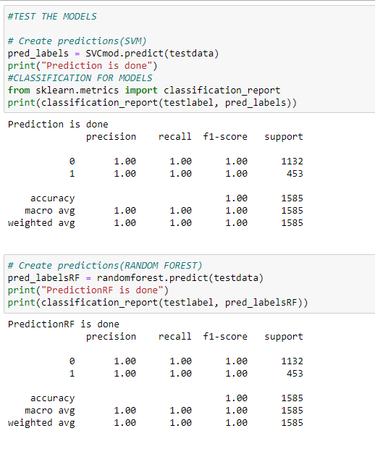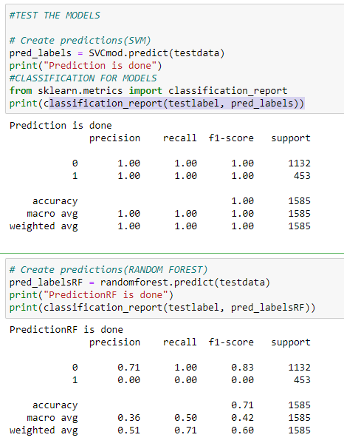

While visualizing the images will optimal parameters we can see that there is no difference between the actual and predicted results which means the accuracy of the model is 100%

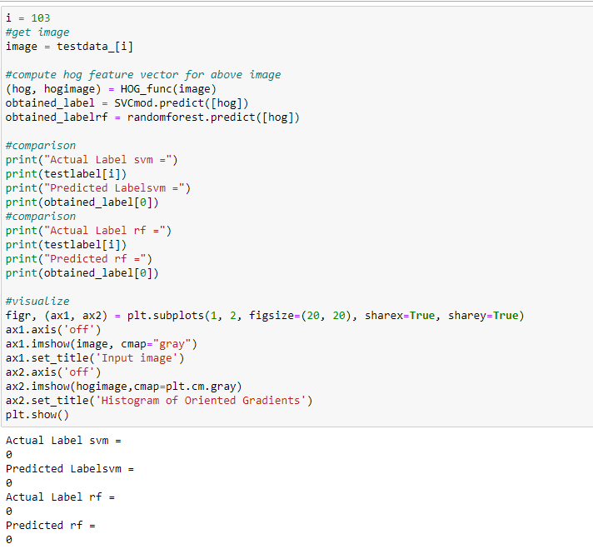

**Task2:**

For this task we have used the Bag of visual words technique. To compute Bag of visual words the first step was to determine the features in an image for a given label (feature extraction). Then we created a visual corpus by clustering and performed frequency analysis. Lastly, we classified the images based on the vocabulary generated by the SVM classifier.

In order to execute the code, we need to fulfill the following requirements:

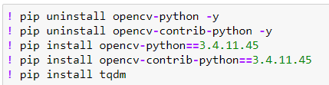

**Objects dataset:**

It was noted that by changing the number of clusters from 50 to either less than 50 or more than 50, the accuracy of the model decreased significantly. By keeping the number of clusters in k mean = 50, we get the highest accuracy of 0.750 i.e. 75%. In the future we can increase the accuracy of the model by adding more data, treating missing values, feature engineering, ensemble methods and algorithm tuning.

The classification report for this model is given as follows:

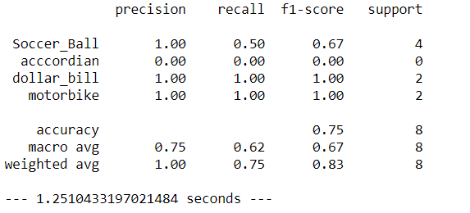

The confusion matrix after applying SVM is given below:

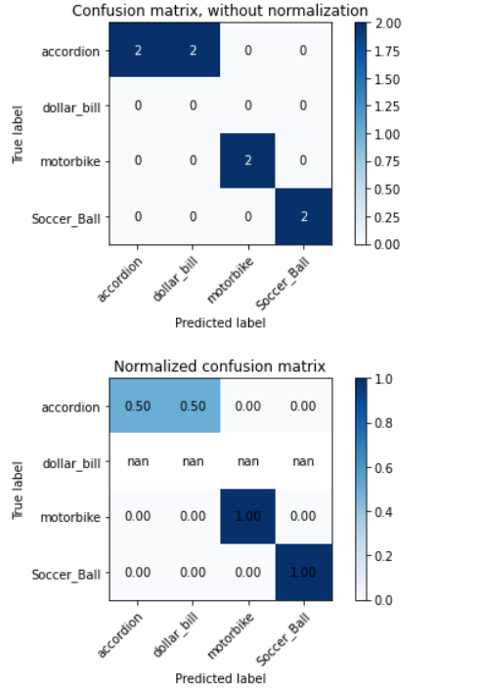

**Flowers dataset:**

It was noted that by changing the number of clusters from 50 to either less than 50 or more than 50, the accuracy of the model decreased significantly. By keeping the number of clusters in k mean = 50, we get the highest accuracy of 0.412 i.e 42%. In the future we can increase the accuracy of the model by adding more data, treating missing values, feature engineering, ensemble methods and algorithm tuning.

The classification report for this model is given as follows:

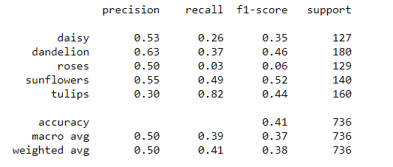

The confusion matrix after applying SVM is given below:

